

***Name: Owami***

***Surname: Jilaji***

***Student Number: ST 10484935***

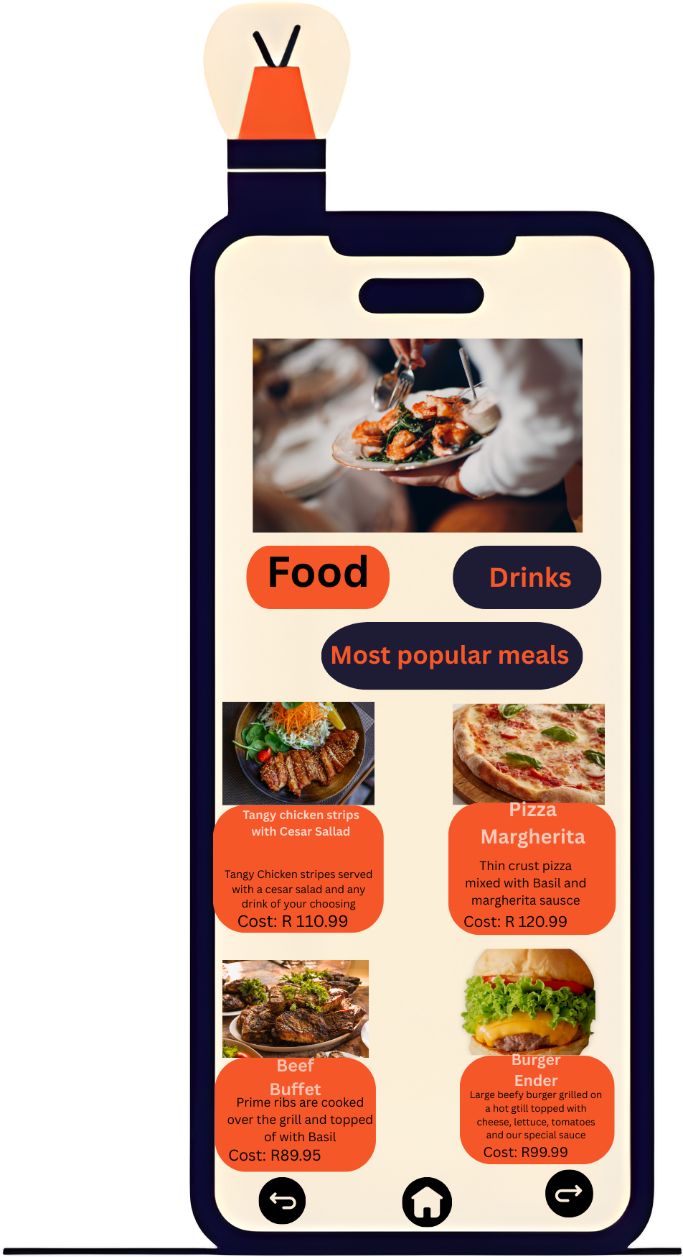

package com.example.foodapp

import android.os.Bundle

import androidx.appcompat.app.AppCompatActivity

import androidx.recyclerview.widget.LinearLayoutManager

import androidx.recyclerview.widget.RecyclerView

class FoodActivity : AppCompatActivity() {

override fun onCreate(savedInstanceState: Bundle?) {

super.onCreate(savedInstanceState)

setContentView(R.layout.activity_food)

val recyclerView: RecyclerView = findViewById(R.id.recyclerViewFood)

recyclerView.layoutManager = LinearLayoutManager(this)

val foodList = listOf(

MenuItem("Tangy Chicken Strips", "With Cesar Salad", "R 110.99", R.drawable.chicken),

MenuItem("Pizza Margherita", "Thin crust with basil", "R 120.99", R.drawable.pizza),

MenuItem("Beef Buffet", "Prime ribs grilled with basil", "R 89.95", R.drawable.beef),

MenuItem("Burger Ender", "Beef burger with cheese & sauce", "R 99.99", R.drawable.burger)

)

recyclerView.adapter = MenuAdapter(foodList)

}

}

<LinearLayout xmlns:android="http://schemas.android.com/apk/res/android"

android:layout_width="match_parent"

android:layout_height="match_parent"

android:orientation="vertical">

<TextView

android:layout_width="match_parent"

android:layout_height="wrap_content"

android:text="Most Popular Meals"

android:gravity="center"

android:textSize="20sp"

android:padding="8dp" />

<androidx.recyclerview.widget.RecyclerView

android:id="@+id/recyclerViewFood"

android:layout_width="match_parent"

android:layout_height="match_parent" />

</LinearLayout>

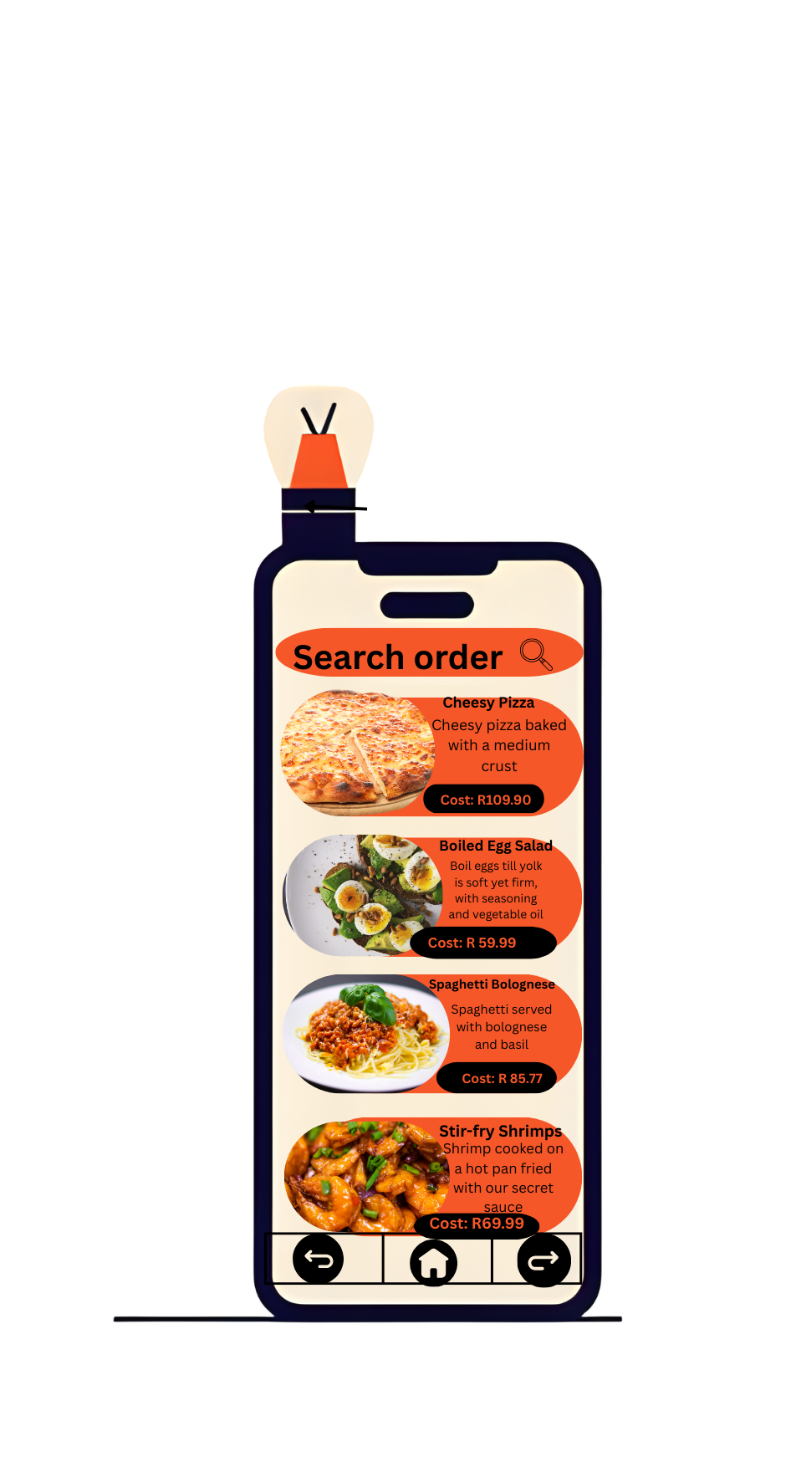

package com.example.foodapp

import android.os.Bundle

import androidx.appcompat.app.AppCompatActivity

import androidx.recyclerview.widget.LinearLayoutManager

import androidx.recyclerview.widget.RecyclerView

class SearchFoodActivity : AppCompatActivity() {

override fun onCreate(savedInstanceState: Bundle?) {

super.onCreate(savedInstanceState)

setContentView(R.layout.activity_search_food)

val recyclerView: RecyclerView = findViewById(R.id.recyclerViewSearchFood)

recyclerView.layoutManager = LinearLayoutManager(this)

val searchFoodList = listOf(

MenuItem("Cheesy Pizza", "Baked with medium crust", "R 109.90", R.drawable.pizza),

MenuItem("Boiled Egg Salad", "Eggs with seasoning", "R 59.99", R.drawable.salad),

MenuItem("Spaghetti Bolognese", "With bolognese and basil", "R 85.77", R.drawable.spaghetti),

MenuItem("Stir-fry Shrimps", "Cooked with secret sauce", "R 69.99", R.drawable.shrimps)

)

recyclerView.adapter = MenuAdapter(searchFoodList)

}

}

<LinearLayout xmlns:android="http://schemas.android.com/apk/res/android"

android:layout_width="match_parent"

android:layout_height="match_parent"

android:orientation="vertical">

<TextView

android:layout_width="match_parent"

android:layout_height="wrap_content"

android:text="Search Order"

android:gravity="center"

android:textSize="20sp"

android:padding="8dp" />

<androidx.recyclerview.widget.RecyclerView

android:id="@+id/recyclerViewSearchFood"

android:layout_width="match_parent"

android:layout_height="match_parent" />

</LinearLayout>

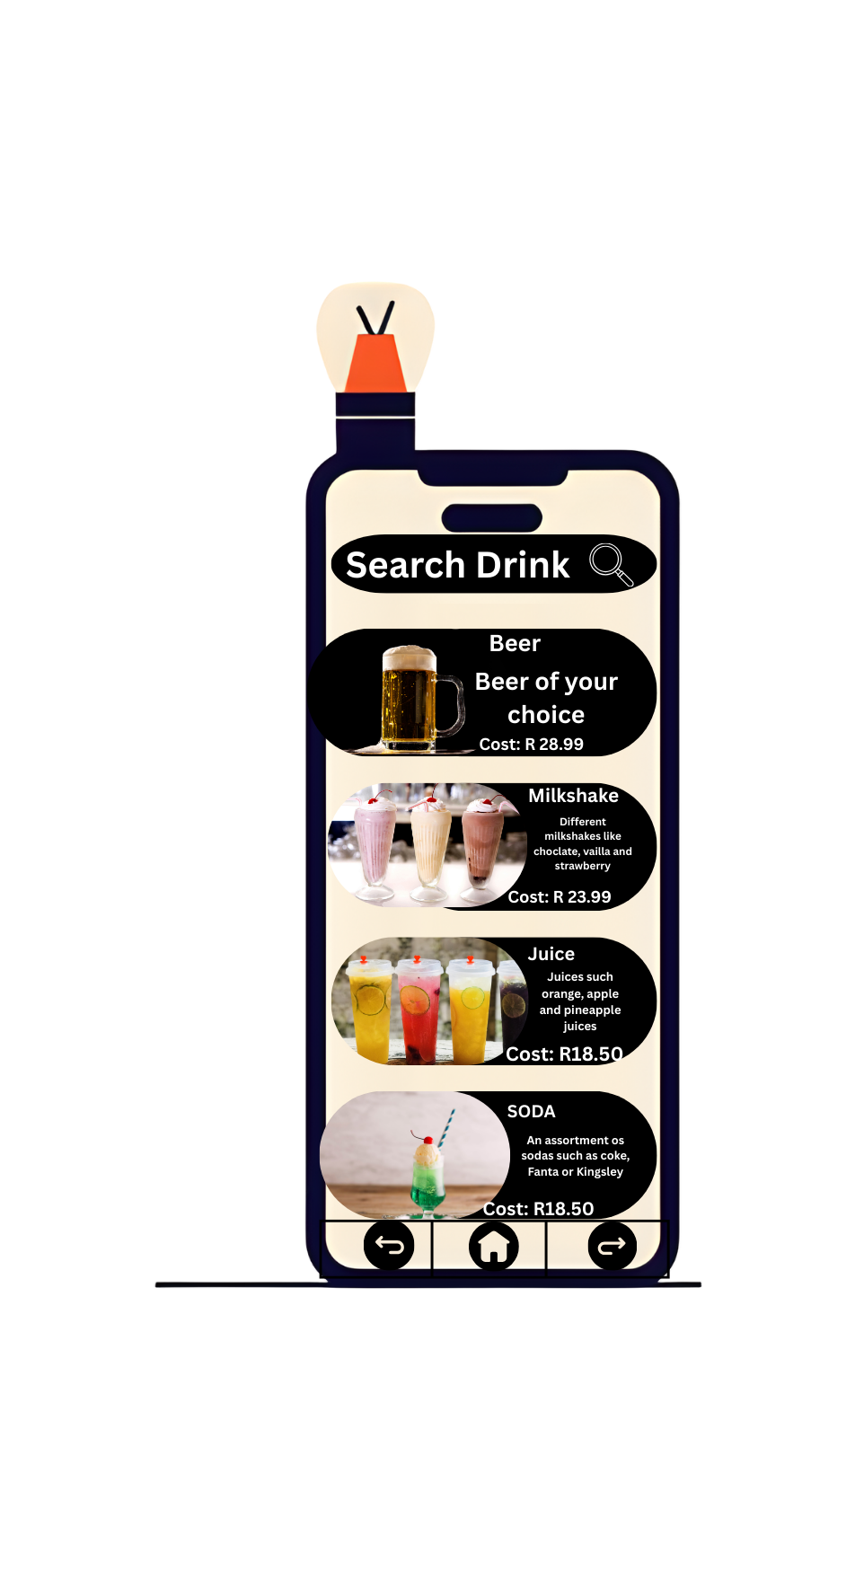

package com.example.foodapp

import android.os.Bundle

import androidx.appcompat.app.AppCompatActivity

import androidx.recyclerview.widget.LinearLayoutManager

import androidx.recyclerview.widget.RecyclerView

class SearchDrinksActivity : AppCompatActivity() {

override fun onCreate(savedInstanceState: Bundle?) {

super.onCreate(savedInstanceState)

setContentView(R.layout.activity_search_drinks)

val recyclerView: RecyclerView = findViewById(R.id.recyclerViewDrinks)

recyclerView.layoutManager = LinearLayoutManager(this)

val drinksList = listOf(

MenuItem("Beer", "Beer of your choice", "R 28.99", R.drawable.beer),

MenuItem("Milkshake", "Chocolate, vanilla, strawberry", "R 23.99", R.drawable.milkshake),

MenuItem("Juice", "Orange, apple, pineapple", "R 18.50", R.drawable.juice),

MenuItem("Soda", "Coke, Fanta, Kingsley", "R 18.50", R.drawable.soda)

)

recyclerView.adapter = MenuAdapter(drinksList)

}

}

<LinearLayout xmlns:android="http://schemas.android.com/apk/res/android"

android:layout_width="match_parent"

android:layout_height="match_parent"

android:orientation="vertical">

<TextView

android:layout_width="match_parent"

android:layout_height="wrap_content"

android:text="Search Drinks"

android:gravity="center"

android:textSize="20sp"

android:padding="8dp" />

<androidx.recyclerview.widget.RecyclerView

android:id="@+id/recyclerViewDrinks"

android:layout_width="match_parent"

android:layout_height="match_parent" />

</LinearLayout>

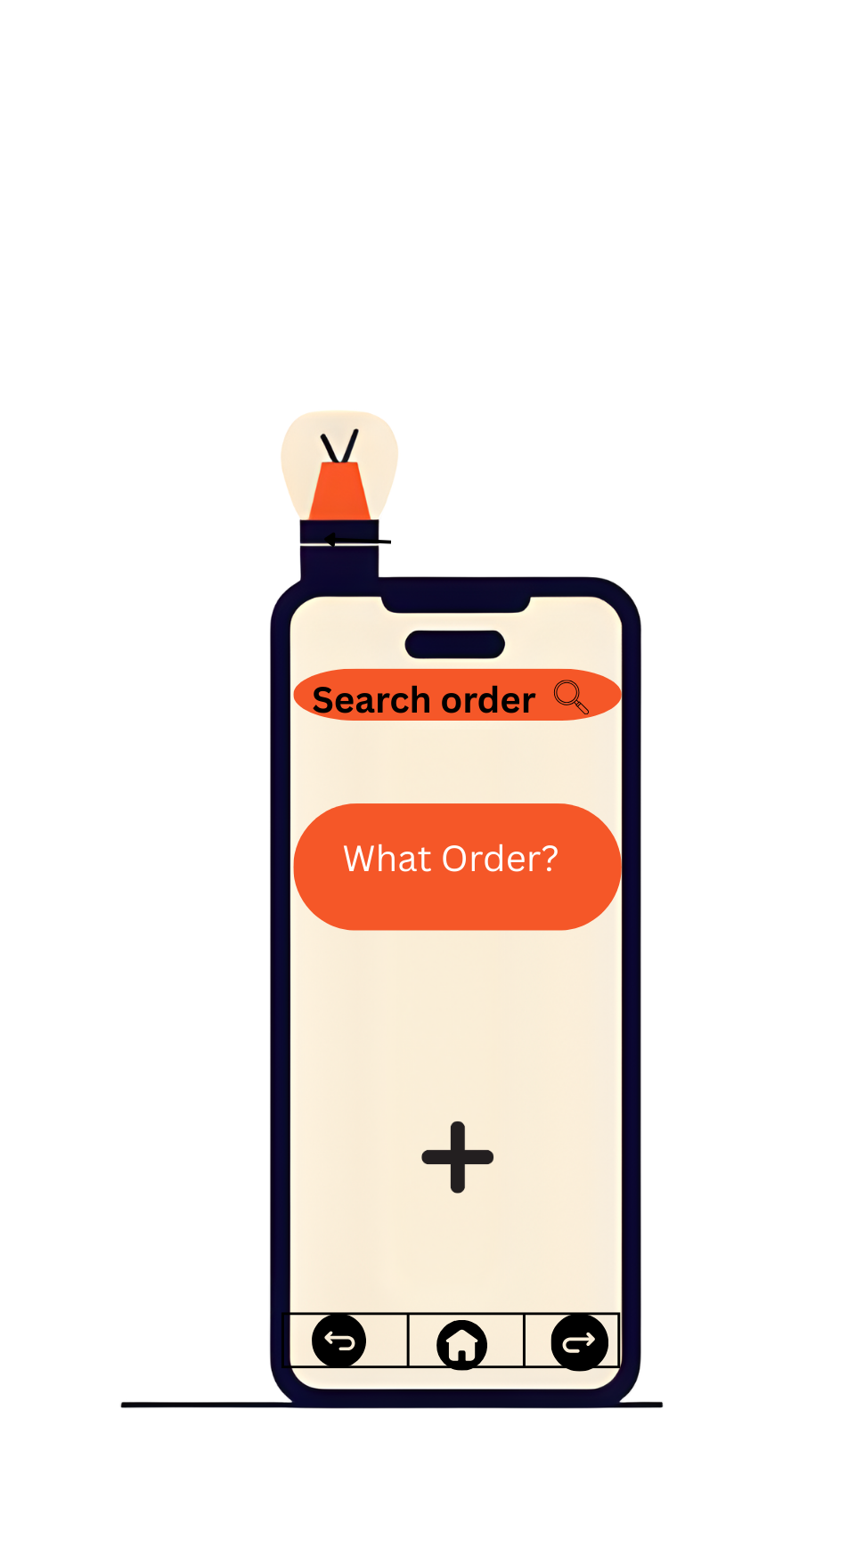

package com.example.foodapp

import android.os.Bundle

import androidx.appcompat.app.AppCompatActivity

import androidx.recyclerview.widget.LinearLayoutManager

import androidx.recyclerview.widget.RecyclerView

class FoodActivity : AppCompatActivity() {

override fun onCreate(savedInstanceState: Bundle?) {

super.onCreate(savedInstanceState)

setContentView(R.layout.activity_food)

val recyclerView: RecyclerView = findViewById(R.id.recyclerViewFood)

recyclerView.layoutManager = LinearLayoutManager(this)

// Sample food items

val foodList = listOf(

MenuItem("Tangy Chicken Strips", "With Cesar Salad", "R 110.99", R.drawable.chicken),

MenuItem("Pizza Margherita", "Thin crust with basil", "R 120.99", R.drawable.pizza),

MenuItem("Beef Buffet", "Prime ribs grilled with basil", "R 89.95", R.drawable.beef),

MenuItem("Burger Ender", "Beef burger with cheese & sauce", "R 99.99", R.drawable.burger)

)

recyclerView.adapter = MenuAdapter(foodList)

}

}